# Appendix A: Diagram – Mapping Ethical Axioms to Ψ-Inference

This appendix presents a visual summary of the central conceptual mapping in the paper: the alignment between five ethical axioms and the principles of ψ-inferential quantum theory. Each axiom corresponds to a structural constraint or requirement in an inferential system operating under conditions of epistemic uncertainty.  
  
These correspondences suggest that the ethical behavior of reflective agents may not be imposed from outside, but instead may arise naturally from the internal logic of inference in uncertain environments.

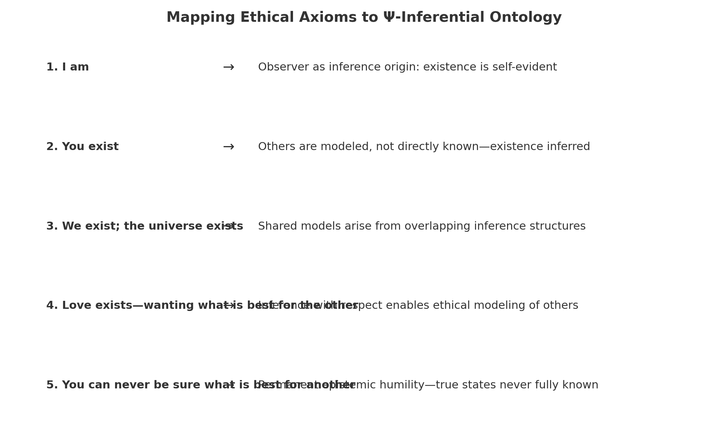

Summary Mapping:  
1. **I am** → Inference requires a localized observing agent.  
2. **You exist** → Other systems are modeled inferentially and cannot be reduced.  
3. **We exist** → Shared regularities define the space in which consistent inference occurs.  
4. **Love exists** → Epistemically humble modeling of others is necessary for stability.  
5. **You can never be sure what is best for another** → Permanent uncertainty limits prescriptive certainty.